Project Design Phase-II

Data Flow Diagram & User Stories

|  |  |
| --- | --- |
| Team ID | PNT2022TMID13652 |
| Project Name | Project – Smart waste management system for metropolitan cities |
| Maximum Marks | 4 Marks |

# Data Flow Diagrams:

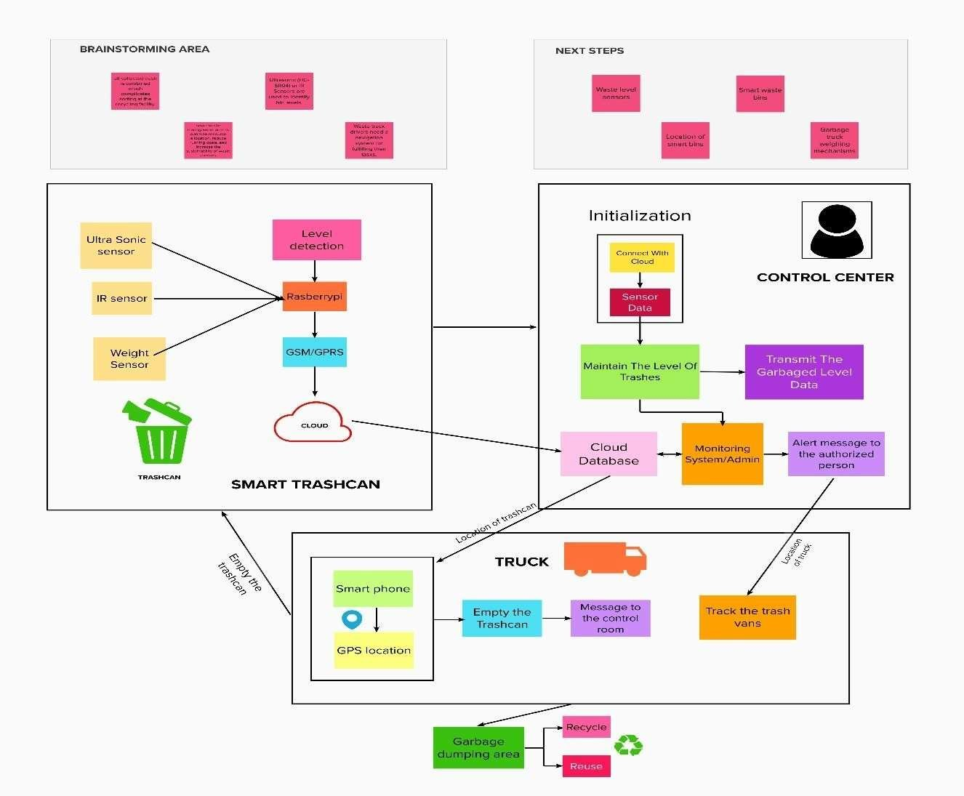

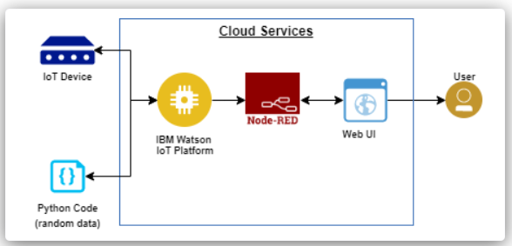

**User Stories**

|  |  |  |  |  |  |  |
| --- | --- | --- | --- | --- | --- | --- |
| **User Type** | **Functional**  **Requirement (Epic)** | **User Story Number** | **User Story / Task** | **Acceptance criteria** | **Priority** | **Release** |
| Admin | Registration | USN-1 | As an admin, I can give the credentials to the login page for every sanitary worker to monitor real time data | I can monitor the system. | High | Sprint-4 |
|  |  | USN-2 | As an admin, I will inform the authorized person to empty the trashcan. | I can inform the  authorised person. | High | Sprint-2 |
|  |  | USN-3 | As an admin, I can notice the trash level of every dustbin every particular period of time | I can notice the trash level. | Low | Sprint-2 |
| Co-Admin | Login | USN-4 | As a Co-Admin, I can send an alert message to the truck drivers about the location of the dustbin to collect the trash | I can alert the truck driver. | Medium | Sprint-1 |
| Driver | Login | USN-5 | As a trash van driver, I will follow the route to the dustbin using location given by the admin team with the help of the global positioning system(GPS) to collect the garbage. | I can reach the  filled trashcans. | High | Sprint-2 |
| Sanitary worker | Dashboard | USN-6 | As a sanitary worker, I will collect all the trash from the bin which has overflowed for every particular period of time. | I can empty the  Trash cans. | Low | Sprint-2 |
| Municipality officer |  | USN-7 | As a municipality officer, I can  supervise the process and ensure the cleanliness of the city. | I can manage all  processes in an efficient manner. | Medium | Sprint-1 |
|  | Login | USN-8 | As a municipality officer, I can initialize  new bins in different location of the cities wherever it required. | I can register new  smart trashcans. | High | Sprint-3 |
|  |  | USN-9 | As a municipality officer, I can check the quality of IOT device’s quality ensure about its working condition and durability. | I can check the IOT device. | Medium | Sprint-3 |